Name:JAGARJUPALLI BHANUPRAKASH REDDY
Reg.No:192524171
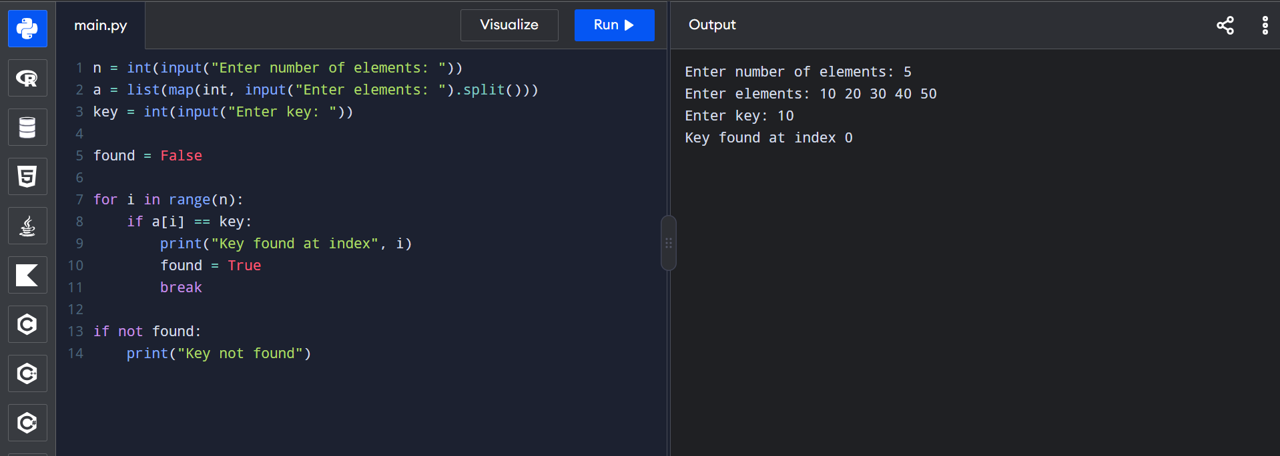
Experiment 1: Linear Search (Iterative)
CODE-
n = int(input("Enter number of elements: "))
a = list(map(int, input("Enter elements: ").split()))
key = int(input("Enter key: "))

found = False

for i in range(n):
if a[i] == key:
print("Key found at index", i)
found = True
break

if not found:
print("Key not found")

Experiment 2: Binary Search (Recursive
CODE-

def binary_search(a, low, high, key):
if low > high:
return -1

mid = (low + high) // 2

if a[mid] == key:
return mid
elif key < a[mid]:
return binary_search(a, low, mid - 1, key)
else:
return binary_search(a, mid + 1, high, key)

a = list(map(int, input("Enter sorted elements: ").split()))
key = int(input("Enter key: "))

result = binary_search(a, 0, len(a) - 1, key)

if result != -1:
print("Key found at index", result)
else:
print("Key not found")
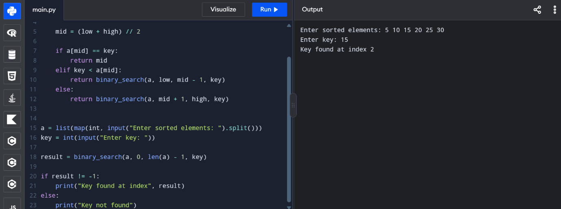
Experiment 3: Factorial (Iterative vs Recursive)
CODE-
def factorial_iterative(n):
fact = 1
for i in range(1, n + 1):
fact *= i
return fact

def factorial_recursive(n):
if n <= 1:
return 1
return n * factorial_recursive(n - 1)

n = int(input("Enter a number: "))

if n < 0:
print("Factorial is not defined for negative numbers")
else:
print("Iterative factorial:", factorial_iterative(n))
print("Recursive factorial:", factorial_recursive(n))
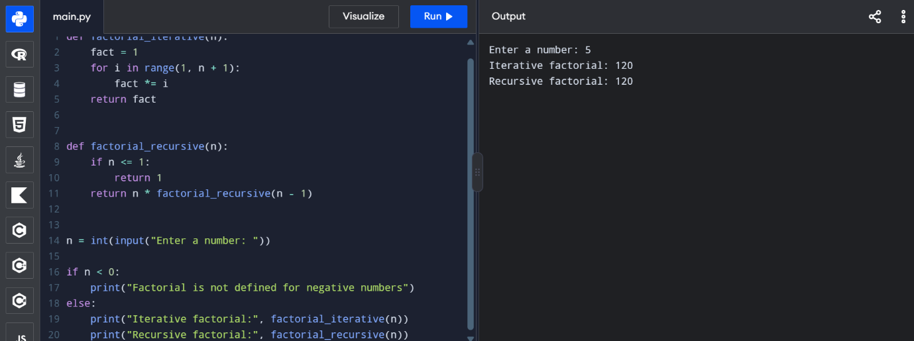
Experiment 4: Fibonacci Series
CODE-
def fibonacci_iterative(n):
a, b = 0, 1
result = []

for i in range(n):
result.append(a)
a, b = b, a + b

return result

def fibonacci_recursive(n):
if n <= 1:
return n
return fibonacci_recursive(n - 1) + fibonacci_recursive(n - 2)

def fibonacci_memo(n, memo):
if n <= 1:
return n
if n not in memo:
memo[n] = fibonacci_memo(n - 1, memo) + fibonacci_memo(n - 2, memo)
return memo[n]

n = int(input("Enter number of terms: "))

if n < 0:
print("Enter a non-negative number")
else:
print("Iterative:", fibonacci_iterative(n))

if n <= 30:
print("Recursive:", [fibonacci_recursive(i) for i in range(n)])
else:
print("Naive recursion skipped for large n")

memo = {}
print("Memoized:", [fibonacci_memo(i, memo) for i in range(n)])
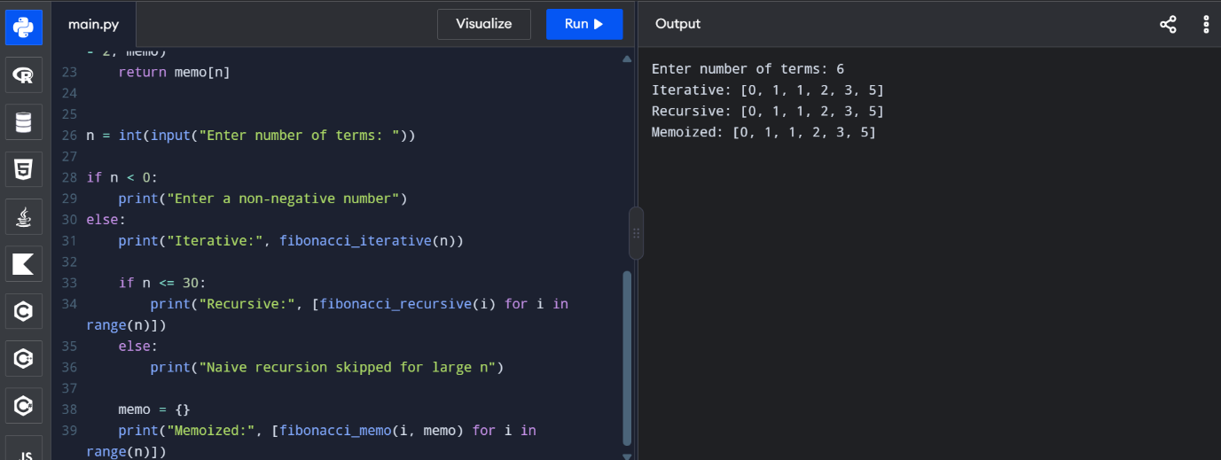
Experiment 5: Matrix Multiplication
CODE-
n = int(input("Enter matrix size: "))

print("Enter first matrix:")
A = [list(map(int, input().split())) for _ in range(n)]

print("Enter second matrix:")
B = [list(map(int, input().split())) for _ in range(n)]

C = [[0] * n for _ in range(n)]

for i in range(n):
for j in range(n):
for k in range(n):
C[i][j] += A[i][k] * B[k][j]

print("Resultant matrix:")
for row in C:
print(*row)
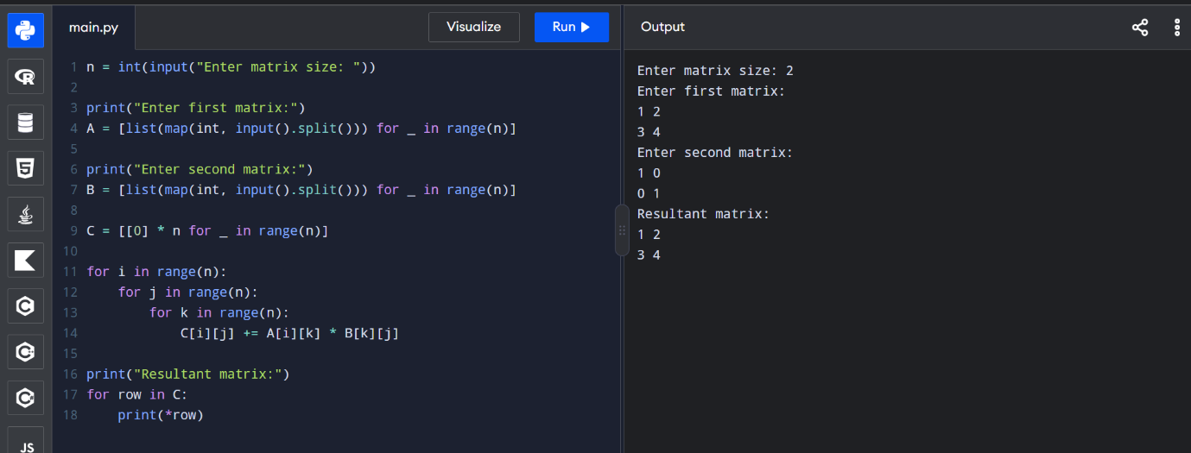

Experiment 6: Merge Sort
def merge_sort(a):
if len(a) <= 1:
return a

mid = len(a) // 2
left = merge_sort(a[:mid])
right = merge_sort(a[mid:])

result = []
i = j = 0

while i < len(left) and j < len(right):
if left[i] <= right[j]:
result.append(left[i])
i += 1
else:
result.append(right[j])
j += 1

result.extend(left[i:])
result.extend(right[j:])
return result

a = list(map(int, input("Enter elements: ").split()))
print("Sorted array:", merge_sort(a))
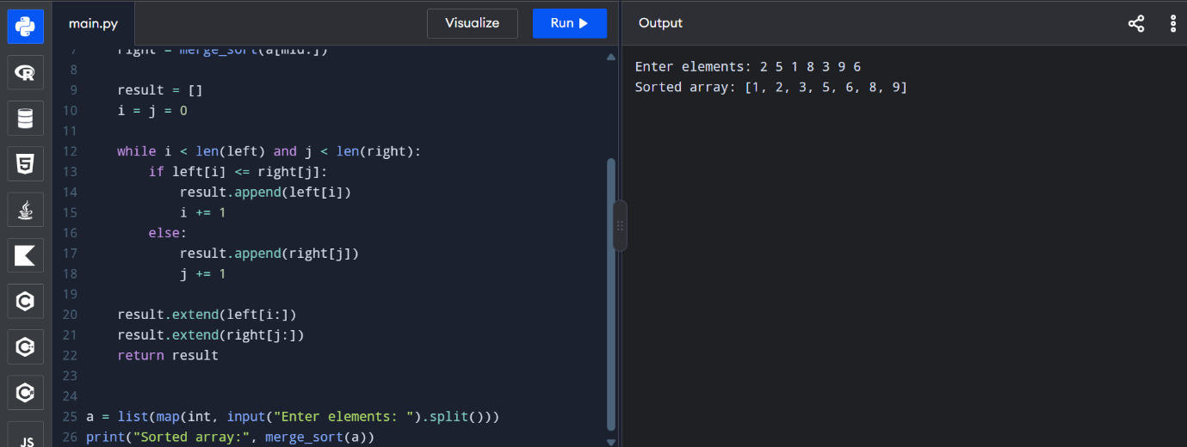

Experiment 7: Quick Sort
CODE-
def quick_sort(a):
if len(a) <= 1:
return a

pivot = a[len(a) // 2]

left = [x for x in a if x < pivot]
middle = [x for x in a if x == pivot]
right = [x for x in a if x > pivot]

return quick_sort(left) + middle + quick_sort(right)

a = list(map(int, input("Enter elements: ").split()))
print("Sorted array:", quick_sort(a))
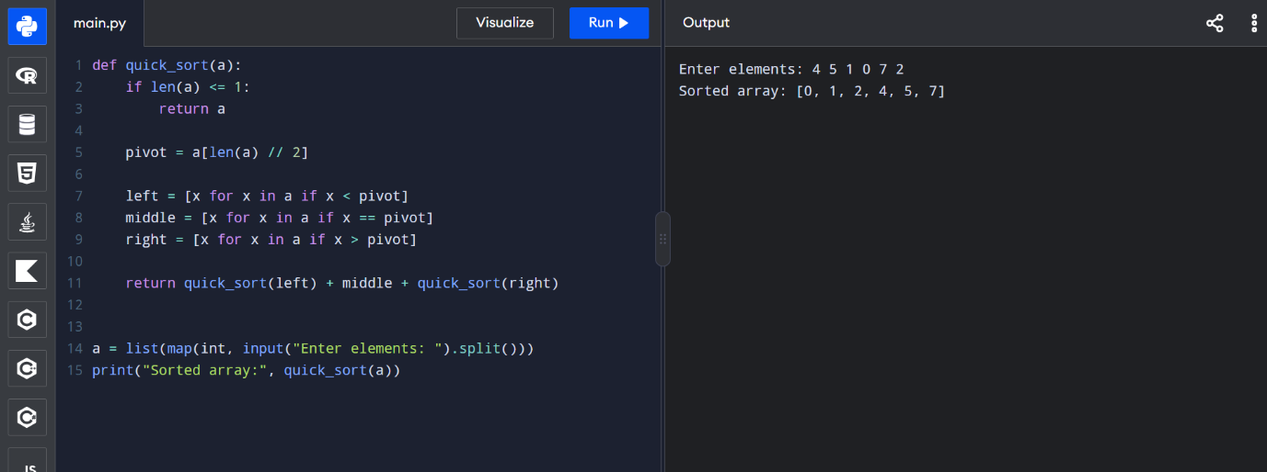
Experiment 8: Tower of Hanoi
CODE-
def tower_of_hanoi(n, source, auxiliary, destination):
if n == 1:
print(source, "->", destination)
return

tower_of_hanoi(n - 1, source, destination, auxiliary)
print(source, "->", destination)
tower_of_hanoi(n - 1, auxiliary, source, destination)

n = int(input("Enter number of disks: "))

if n <= 0:
print("Enter a positive number")
else:
tower_of_hanoi(n, 'A', 'B', 'C')
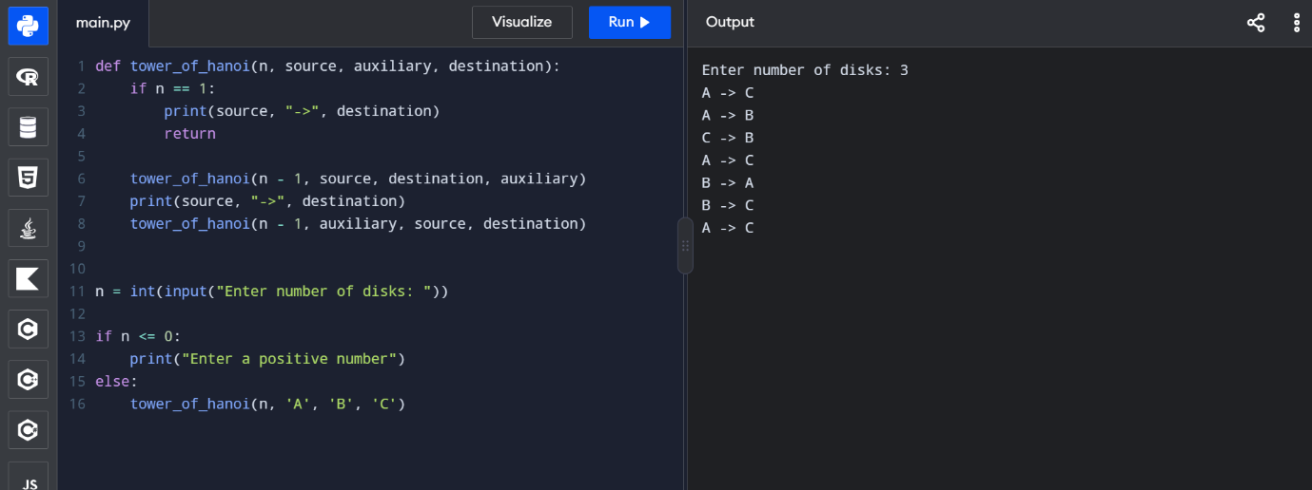
Experiment 9: GCD (Euclidean Algorithm)
CODE-
def gcd(a, b):
a, b = abs(a), abs(b)

if b == 0:
return a

return gcd(b, a % b)

a = int(input("Enter first number: "))
b = int(input("Enter second number: "))

print("GCD:", gcd(a, b))
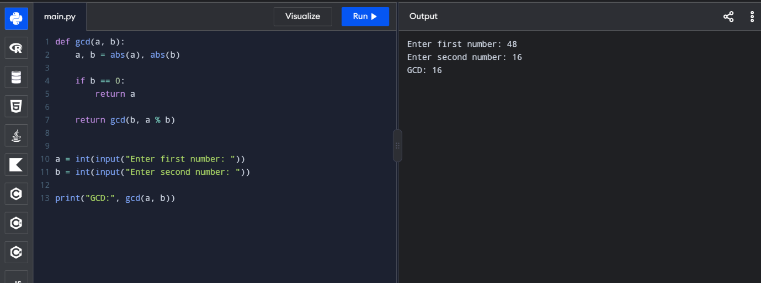
Experiment 10: Insertion Sort
CODE-
def insertion_sort(a):
for i in range(1, len(a)):
key = a[i]
j = i - 1

while j >= 0 and a[j] > key:
a[j + 1] = a[j]
j -= 1

a[j + 1] = key

return a

a = list(map(int, input("Enter elements: ").split()))
print("Sorted array:", insertion_sort(a))
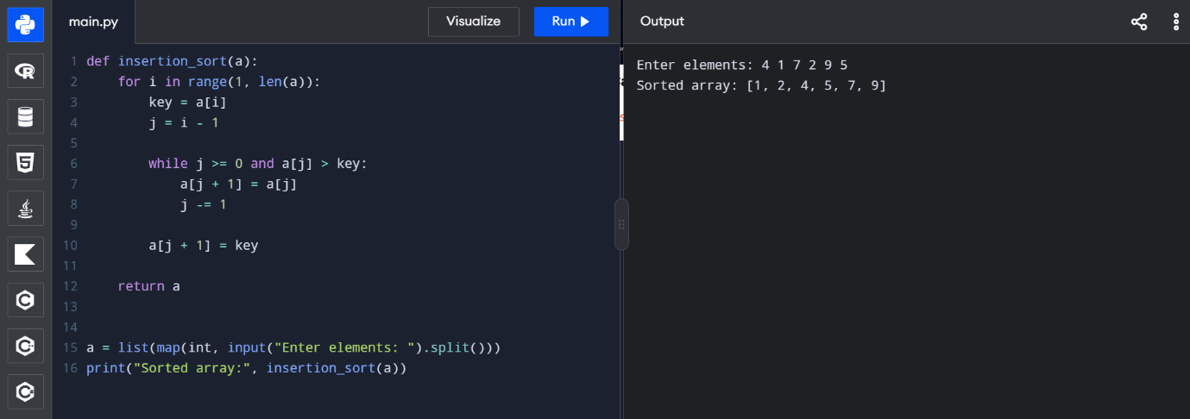
Experiment 11: Heap Sort
CODE-
def heapify(a, n, i):
largest = i
left = 2 * i + 1
right = 2 * i + 2

if left < n and a[left] > a[largest]:
largest = left

if right < n and a[right] > a[largest]:
largest = right

if largest != i:
a[i], a[largest] = a[largest], a[i]
heapify(a, n, largest)

def heap_sort(a):
n = len(a)

for i in range(n // 2 - 1, -1, -1):
heapify(a, n, i)

for i in range(n - 1, 0, -1):
a[0], a[i] = a[i], a[0]
heapify(a, i, 0)

return a

a = list(map(int, input("Enter elements: ").split()))
print("Sorted array:", heap_sort(a))
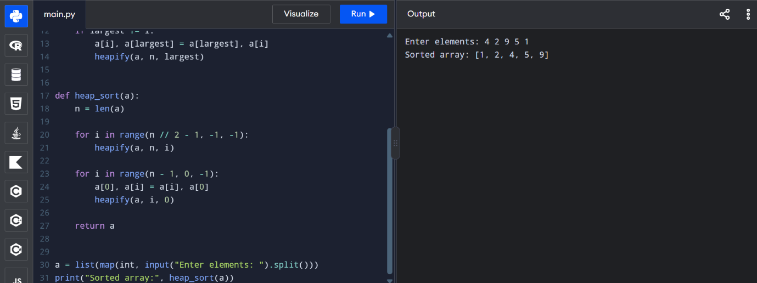
Experiment 12: Counting Inversions
CODE-
def merge_count(a):
if len(a) <= 1:
return a, 0

mid = len(a) // 2
left, count_left = merge_count(a[:mid])
right, count_right = merge_count(a[mid:])

merged = []
i = j = 0
count = count_left + count_right

while i < len(left) and j < len(right):
if left[i] <= right[j]:
merged.append(left[i])
i += 1
else:
merged.append(right[j])
count += len(left) - i
j += 1

merged.extend(left[i:])
merged.extend(right[j:])

return merged, count

a = list(map(int, input("Enter elements: ").split()))
sorted_array, inversions = merge_count(a)

print("Sorted array:", sorted_array)
print("Number of inversions:", inversions)
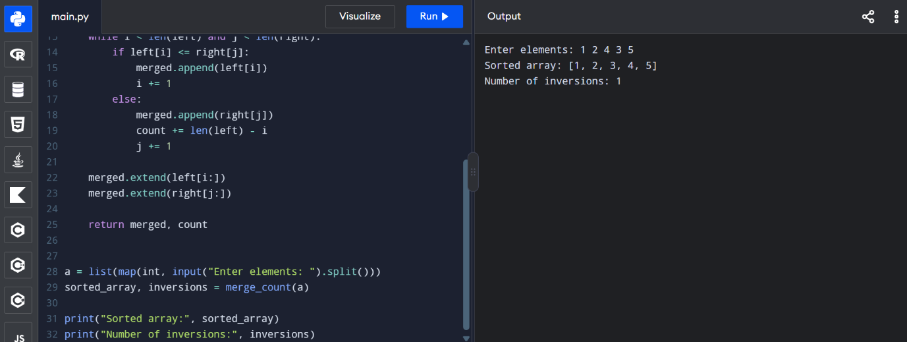
Experiment 13: Maximum Subarray Sum
CODE-
def kadane(a):
current = maximum = a[0]

for x in a[1:]:
current = max(x, current + x)
maximum = max(maximum, current)

return maximum

def divide_conquer(a, low, high):
if low == high:
return a[low]

mid = (low + high) // 2

left_sum = divide_conquer(a, low, mid)
right_sum = divide_conquer(a, mid + 1, high)

left_max = float('-inf')
total = 0
for i in range(mid, low - 1, -1):
total += a[i]
left_max = max(left_max, total)

right_max = float('-inf')
total = 0
for i in range(mid + 1, high + 1):
total += a[i]
right_max = max(right_max, total)

cross_sum = left_max + right_max

return max(left_sum, right_sum, cross_sum)

a = list(map(int, input("Enter elements: ").split()))

if not a:
print("Array cannot be empty")
else:
print("Kadane's result:", kadane(a))
print("Divide and conquer result:",
divide_conquer(a, 0, len(a) - 1))
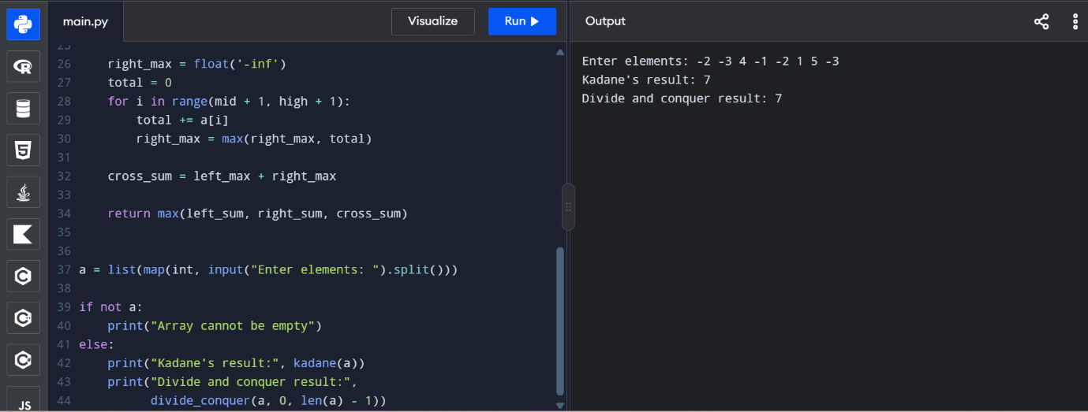
Experiment 14: Exponentiation
CODE-
def iterative_power(x, n):
result = 1

for i in range(n):
result *= x

return result

def fast_power(x, n):
if n == 0:
return 1

half = fast_power(x, n // 2)
result = half * half

if n % 2 == 1:
result *= x

return result

x = float(input("Enter base: "))
n = int(input("Enter non-negative exponent: "))

if n < 0:
print("Enter a non-negative exponent")
else:
print("Iterative result:", iterative_power(x, n))
print("Recursive fast power:", fast_power(x, n))

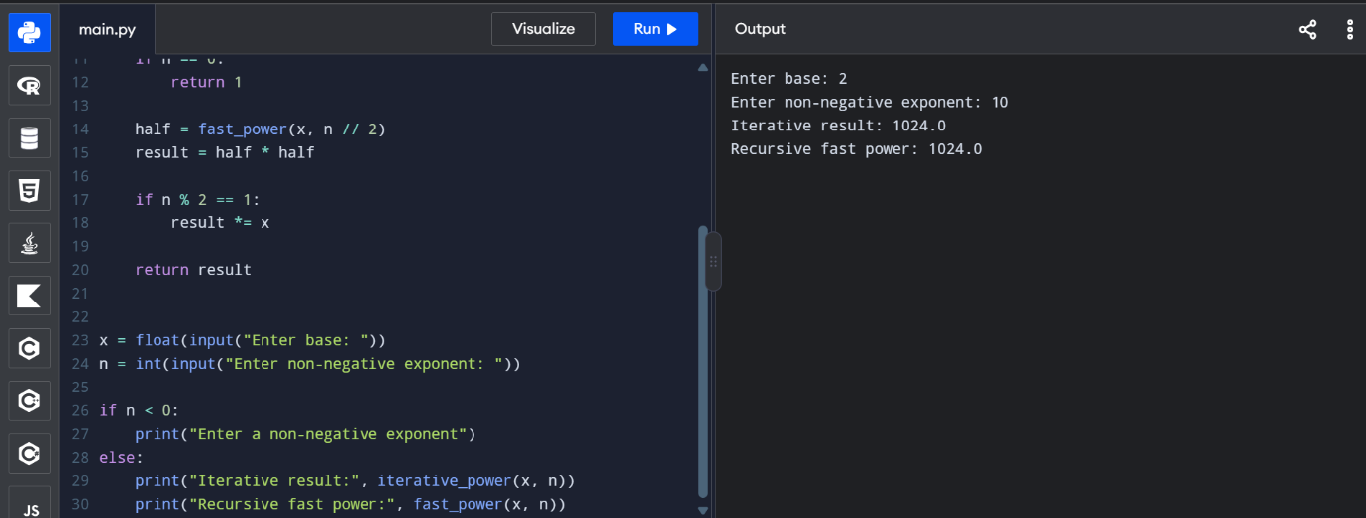
Experiment 15: Closest Pair of Points
CODE-
import math

def brute_force(points):
best = float('inf')
pair = None

for i in range(len(points)):
for j in range(i + 1, len(points)):
d = math.dist(points[i], points[j])
if d < best:
best = d
pair = (points[i], points[j])

return pair, best

def closest_pair(points):
if len(points) < 2:
return None, float('inf')

px = sorted([(x, y, i) for i, (x, y) in enumerate(points)])
py = sorted(px, key=lambda p: (p[1], p[0]))

def solve(px, py):
n = len(px)

if n <= 3:
best = float('inf')
pair = None
for i in range(n):
for j in range(i + 1, n):
d = math.dist(px[i][:2], px[j][:2])
if d < best:
best = d
pair = (px[i][:2], px[j][:2])
return pair, best

mid = n // 2
left_x = px[:mid]
right_x = px[mid:]
left_ids = {p[2] for p in left_x}

left_y = [p for p in py if p[2] in left_ids]
right_y = [p for p in py if p[2] not in left_ids]

pair_l, dist_l = solve(left_x, left_y)
pair_r, dist_r = solve(right_x, right_y)

if dist_l <= dist_r:
best_pair, best = pair_l, dist_l
else:
best_pair, best = pair_r, dist_r

mid_x = px[mid][0]
strip = [p for p in py if abs(p[0] - mid_x) < best]

for i in range(len(strip)):
j = i + 1
while j < len(strip) and strip[j][1] - strip[i][1] < best:
d = math.dist(strip[i][:2], strip[j][:2])
if d < best:
best = d
best_pair = (strip[i][:2], strip[j][:2])
j += 1

return best_pair, best

return solve(px, py)

n = int(input("Enter number of points: "))
points = []

for i in range(n):
x, y = map(float, input(f"Enter point {i + 1} (x y): ").split())
points.append((x, y))

if n < 2:
print("Enter at least two points")
else:
pair1, distance1 = brute_force(points)
pair2, distance2 = closest_pair(points)

print("Brute force closest pair:", pair1)
print("Brute force distance:", round(distance1, 4))
print("Optimized closest pair:", pair2)
print("Optimized distance:", round(distance2, 4))
